Problem 3

Graph the frequency spectrum of the following periodic functions:

1. 
2. 
3. 

Solve:

1.  (12)

Periodic function could be written as Fourier Series equation:

 (13)

By insert equation (12) to (13). We could find:

,,

Since the equation of spectrumis:

 (14)

So if take result of A and B to equation (14)



The plot is:

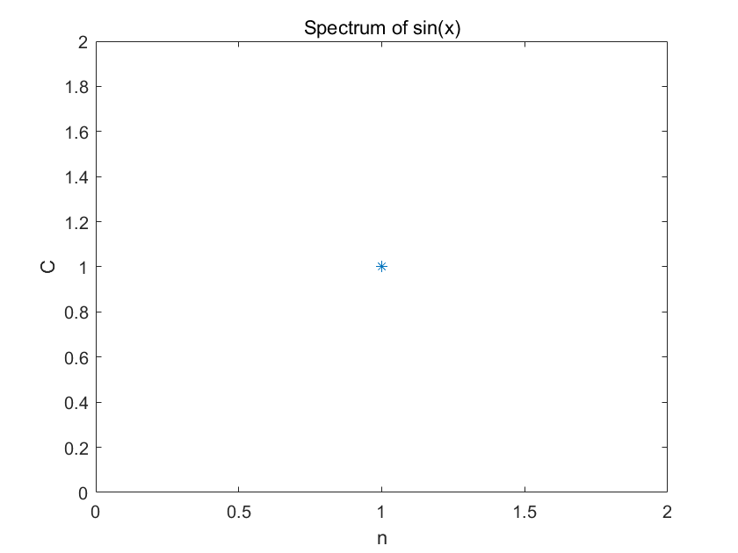

Fig 3.1 The plot of spectrum of sin(x) on the point n=1 is 1

(b) (15)

From the equation (13) we could get

,,

,,

So we could plug this two conditions to (14):





So the graph of the spectrum is:

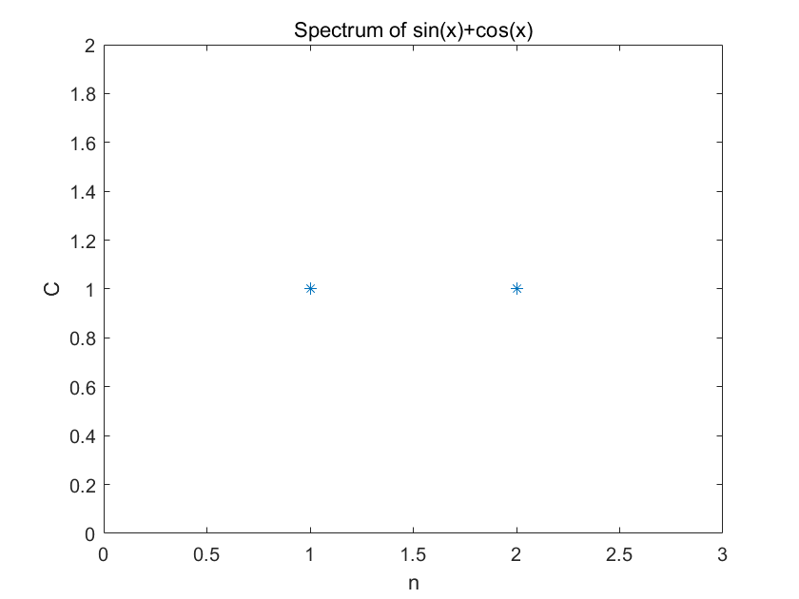

Fig3.2 The plot of spectrum of sin(x)+cos(x) on the point n=1 is 1, on the point n=2 is 1

(c) (15)

From the equation (13) we could get

,,

,,

,,

So we could plug this two conditions to (14):





So the graph of the spectrum is:

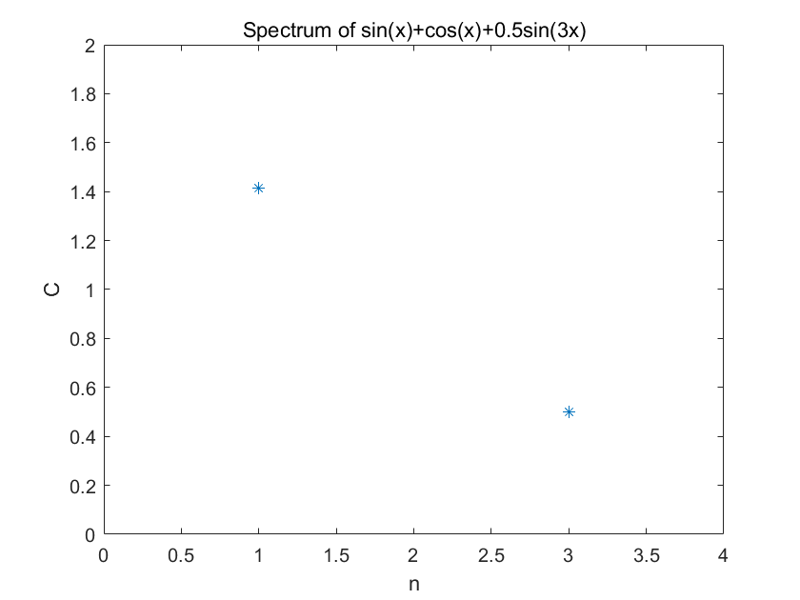

Fig 3.2 The plot of spectrum of sin(x)+cos(x) on the point n=1 is sqrt(2), on the point n=3 is 0.5